**Homework Assignment 4: Harris, SIFT, RANSAC**

1. Harris corners
   1. Gradient pair images

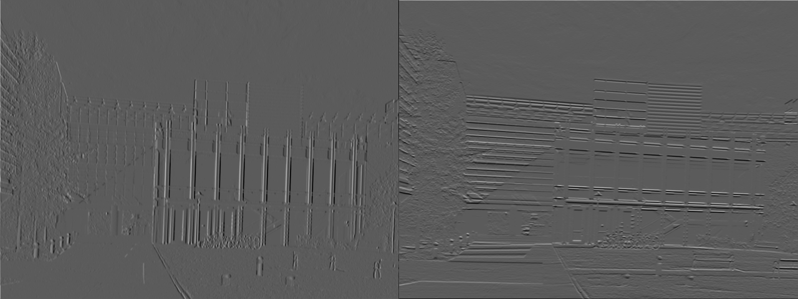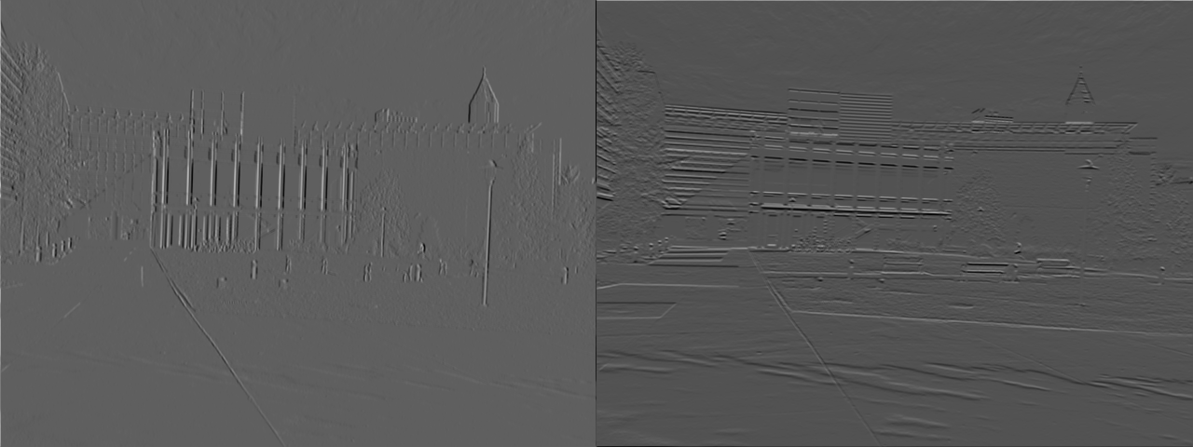

* 1. Harris value output image

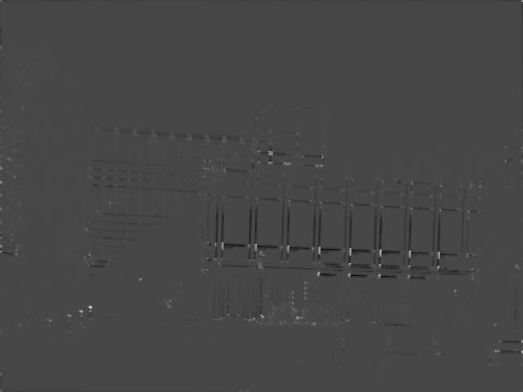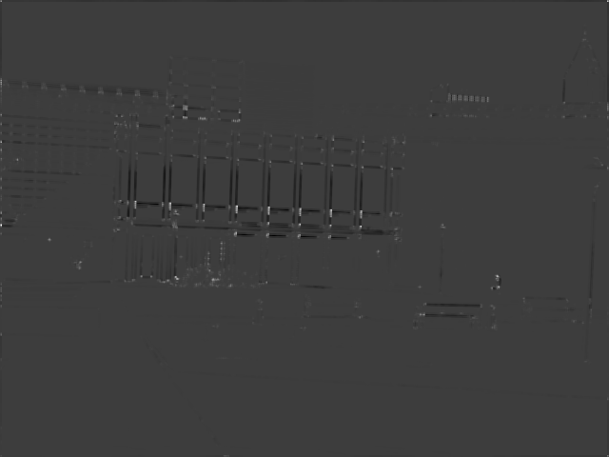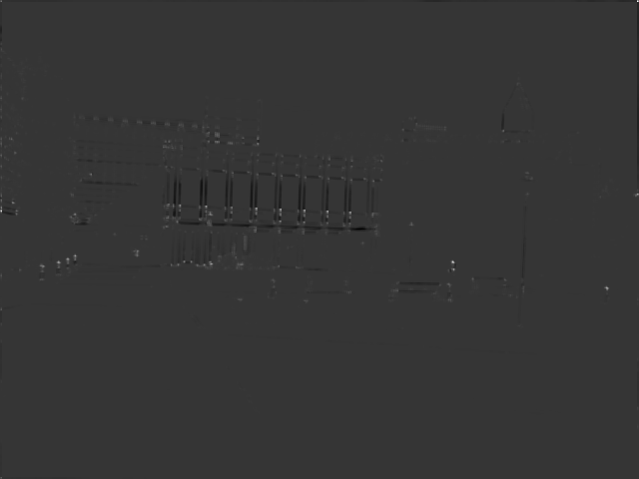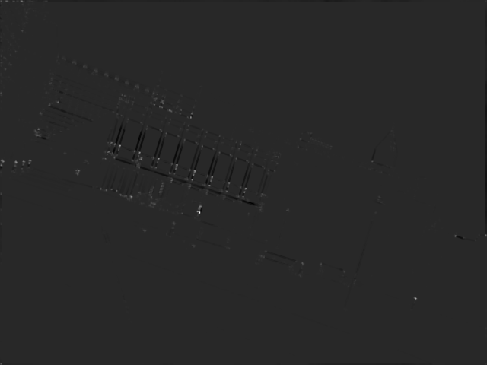

* 1. Image with marked Harris corners

**Describe the behavior of your corner detector including anything surprising, such as points not found in both images of a pair.**

Corner detector finds a lot of similar points in both of the images. Corners that are located on the edges of an image are more easily located than the ones in the middle of an image, so each image find points on the edges of the image that aren’t found in the transformed image. Additionally, in order to find approximately same number of points in the images, different threshold had to be used for each image (smaller threshold for similarity than translation). In this case, I set my thresholds to the following:

transA threshold = 0.35 * max_pixel_intensity

transB threshold = 0.30 * max_pixel_intensity

simA threshold = 0.25 * max_pixel_intensity

simB threshold = 0.20 * max_pixel_intensity

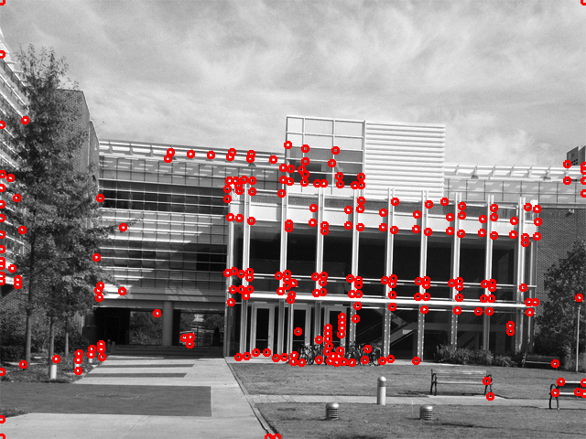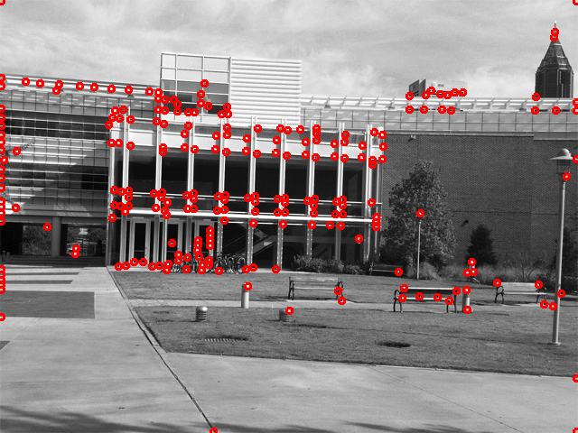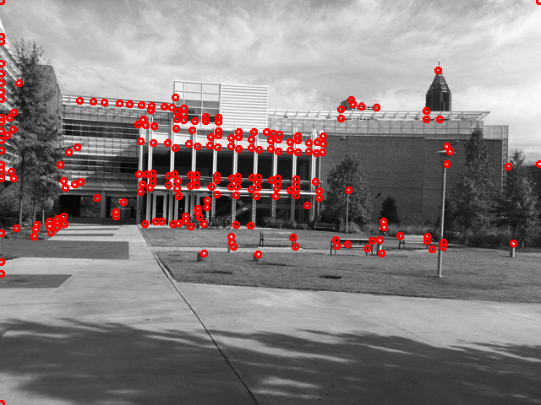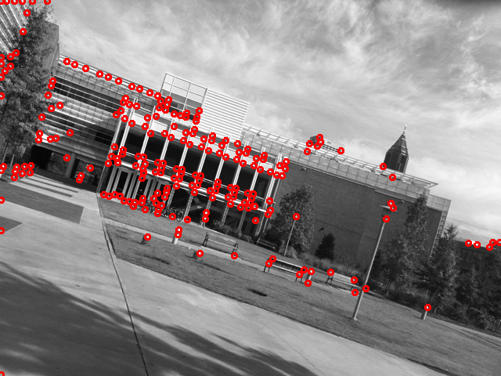

1. SIFT features
   1. Interest points with angles shown

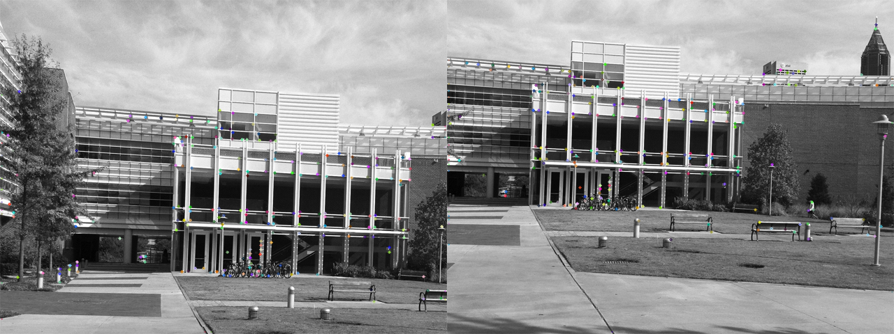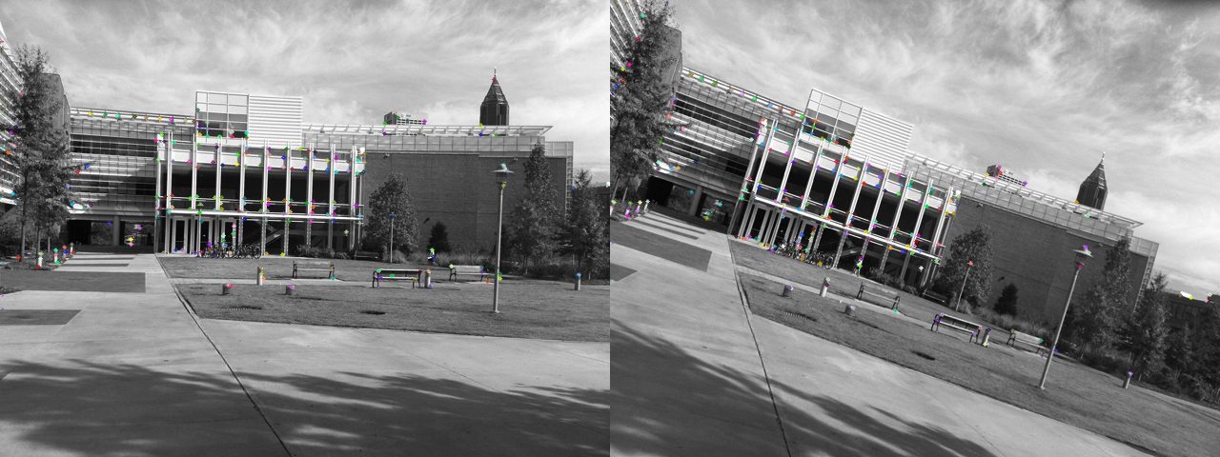

* 1. Putative pair image

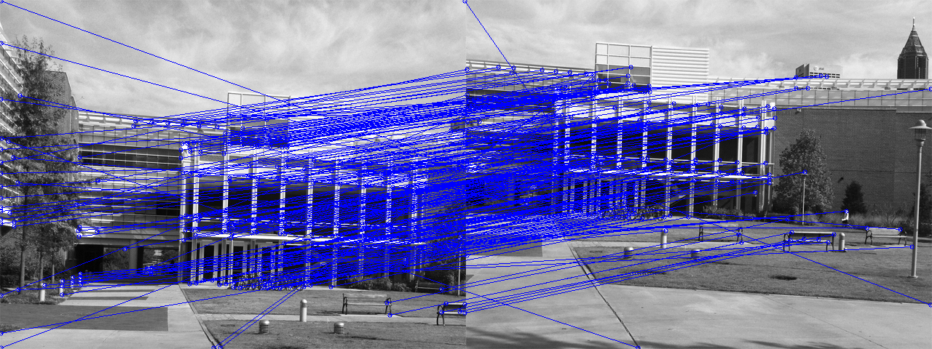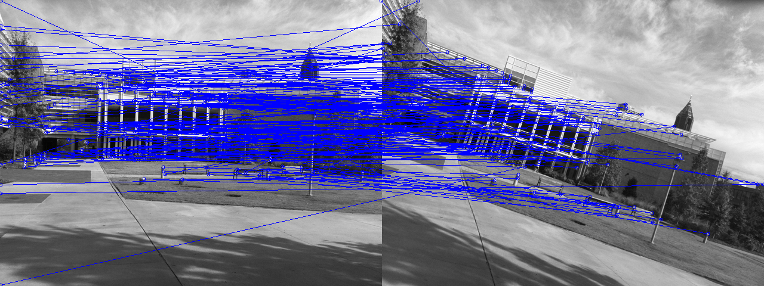

1. RANSAC
   1. Biggest consensus set lines drawn on translation pair

**What translation vector was used?**

Best offset: [154 78]

**What percentage of your matches was the biggest consensus set?**

84.5493562232 %

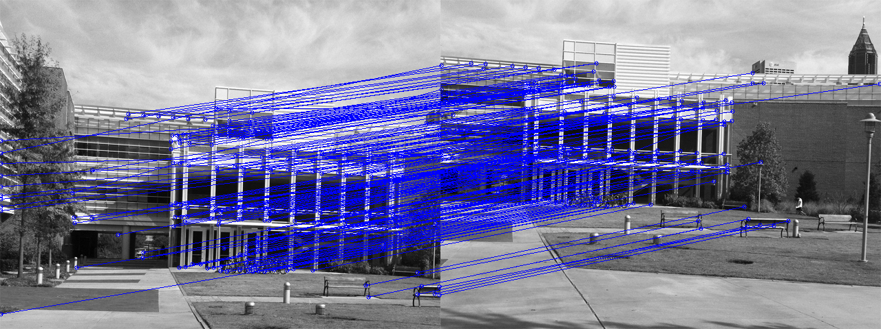

* 1. Biggest consensus set lines drawn on similarity pair

**What is the transform matrix for the best set?**

Best similarity transform:

[[ -2.59306804e-01 1.23234917e-01 1.13607189e+00]

[ -1.23234917e-01 -2.59306804e-01 2.94382542e+02]]

**What percentage of your matches was the biggest consensus set?**

10.3603603604 %

